

**CSE 310**

**JAVA**



Report

**Chatbot application**

|  |  |  |
| --- | --- | --- |
| **Name** | **Regno** | **Roll no** |
| Vinay sai naidu | 12112561 | 03 |
| Naveen | 12113219 | 05 |
| Anil kumar | 12112197 | 59 |

**SUBMITED TO :- Dr.Bhimasen Moharana**

“School of Computer Science & Engineering”

**Lovely Professional University Phagwara, Punjab.**

**Contribution:**

|  |  |
| --- | --- |
| Regno | Contribution |
| 12112561 | Food field |
| 12113219 | Medicine field |
| 12112197 | e-commerce field |

**Abstract:**

A chatbot is a tool that provides online communication platform with an agent and is usually used by organizations as a customer service agent to promote their products and deliver help services on their web, apps or instant messaging platforms like Telegram and WhatsApp. It also has been increasingly used in education to assist students as a virtual tutor in different subject areas. However, there are many questions about the potential and the limits of the use of chatbots for learning a programming language. Nowadays, as education is shifting towards Education 4.0, its system must adapt to new circumstances and changes in roles. The use of chatbot as a substitution in the process of learning may act as a virtual learning tutor to fulfil the need of education towards Education 4.0. This project exploits a rule-based technique, to generate a solution for finding a suitable control structure for a given computational problem. While text matching is deployed to automatically give instant responses to the users based on template-based questions such as greetings and general theoretical questions. The initial purpose of this project is to develop a virtual tutoring tool that provides support to students on JAVA programming language problems. The result shows there is a significant output produced by the e-JAVA chatbot.

**Context:**

A chatbot is an artificial intelligence program that can simulate a conversation with a user through text or voice. In a Java chatbot project, the main goal is to create a program that can understand and respond to user inputs in a natural language.

The chatbot project can be designed for various purposes such as customer support, virtual assistants, or gaming. The chatbot project can be built using various Java libraries and frameworks, including natural language processing (NLP) libraries like Stanford NLP, Apache OpenNLP, or NLTK.

The main components of a Java chatbot project include:

* User Interface - The user interface is responsible for capturing user inputs and displaying responses.
* Natural Language Processing - The NLP component of the chatbot is responsible for analyzing the user's inputs and understanding the user's intent.
* Dialogue Management - The dialogue management component of the chatbot is responsible for selecting the appropriate response based on the user's input and the chatbot's knowledge.
* Knowledge Base - The knowledge base is the database of information that the chatbot uses to provide responses to user inputs.
* Integration - The chatbot can be integrated with other systems and services to provide a more comprehensive user experience.

**Introduction:**

Welcome to the world of chatbot development using Java! Chatbots are becoming increasingly popular in various industries, from customer support to personal assistants. They are intelligent programs that can simulate conversations with humans through text or voice, and they can understand natural language inputs to provide appropriate responses.

Java is a powerful programming language that is widely used in the development of chatbots due to its scalability, flexibility, and robustness. In this project, we will be developing a chatbot in Java that can understand natural language inputs, analyze them, and generate appropriate responses.

The chatbot will be designed to handle various scenarios, including customer support, information retrieval, and other tasks based on the chatbot's intended purpose. The chatbot's knowledge base will be built using a combination of machine learning and data-driven approaches, and it will be continually updated to improve its accuracy and effectiveness.

This project will involve various components, including the user interface, natural language processing, dialogue management, knowledge base, and integration with external systems and services. These components will work together to create a seamless and intuitive experience for the user.

By the end of this project, you will have a solid understanding of chatbot development using Java, and you will have created a fully functional chatbot that can understand and respond to user inputs in a natural and engaging way. So, let's get started and build an amazing chatbot!

**Software:**

* Jdk: JDK (Java Development Kit) is a software development kit used to develop Java applications. It includes a set of programming tools, such as a compiler, interpreter, and libraries, to help developers create Java applications.The JDK contains two main components: the Java Runtime Environment (JRE) and the Java Development Kit itself. The JRE is responsible for running Java applications, while the JDK provides tools for developing and debugging Java applications.
* Swing: Swing is a graphical user interface (GUI) toolkit for Java. It provides a rich set of GUI components that can be used to create user interfaces for desktop applications. Swing was introduced in Java 2 (JDK 1.2) and has been an integral part of the Java platform ever since.
* Awt: AWT (Abstract Window Toolkit) is the original GUI toolkit for Java. It was introduced in the first version of Java and provided a set of basic components for building user interfaces. AWT is part of the core Java API and is included in all Java implementations.

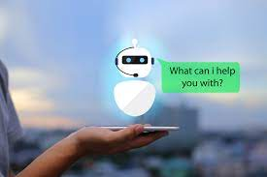

DFD:

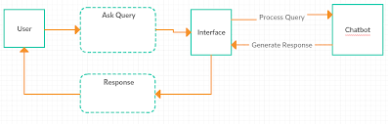

**ER DIAGRAM:**

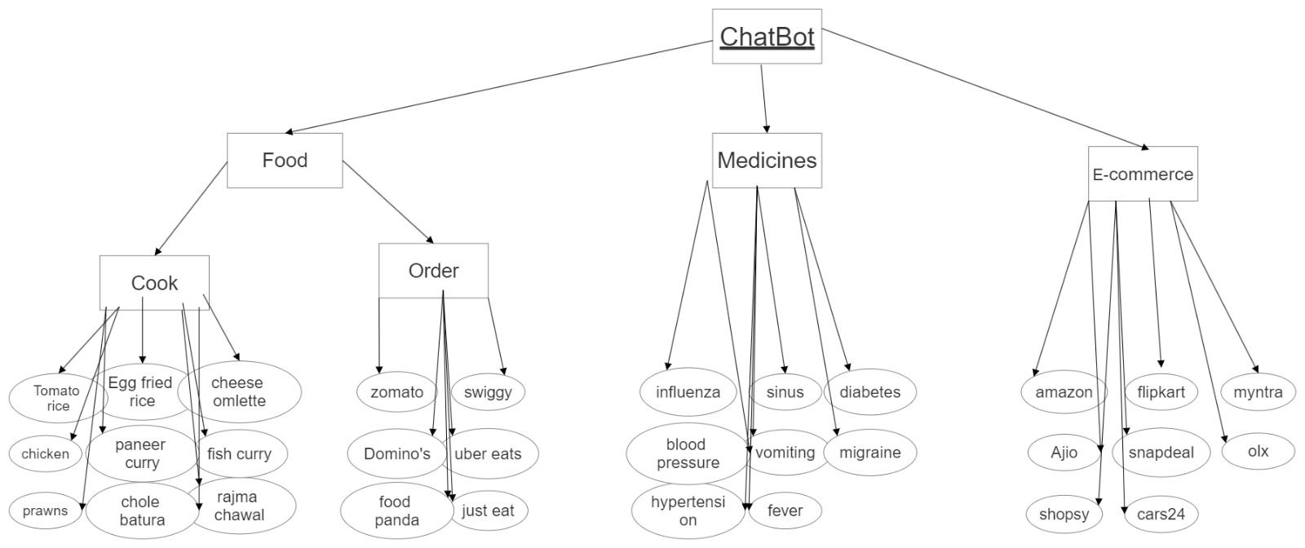

**Brief explanation:**

The GUI contains a text area for displaying chat messages, a text field for inputting text, and a button for sending the input to the chatbot. The chatbot is programmed to respond to certain keywords with pre-defined responses using a HashMap.

Here's a breakdown of the code:

* The first line imports the necessary classes from the Swing and AWT libraries.
* The ChatBotGUI class extends the JFrame class, which provides a basic window for the GUI.
* The JTextArea, JTextField, and JButton classes are used to define the chat area, input field, and send button respectively. A HashMap is also defined to store the responses.
* The ChatBotGUI constructor sets up the GUI window by setting the title, closing operation, resizable option, and location. It then creates the chat area using a JScrollPane to add a scroll bar and sets its preferred size. The input field and send button are also created with an ActionListener to respond to user input.
* A JPanel is created to hold the input field and send button, which is then added to the main content pane using a BorderLayout. The chat area is added to the center of the content pane.
* The pack() method is called to size the window to fit its contents, and the window is made visible.
* The responses HashMap is initialized with pre-defined responses for certain keywords/phrases.
* Overall, this code sets up a basic GUI for a chatbot and defines the chatbot's responses using a HashMap.

**Outputs:**

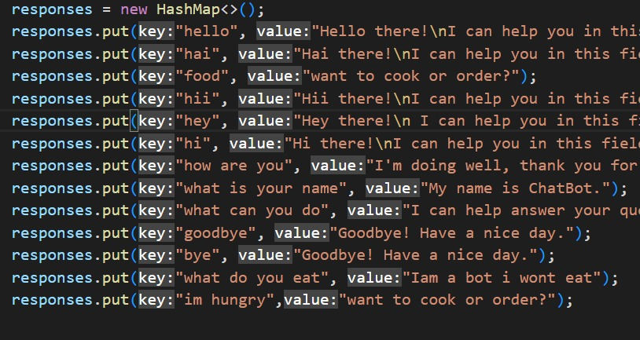

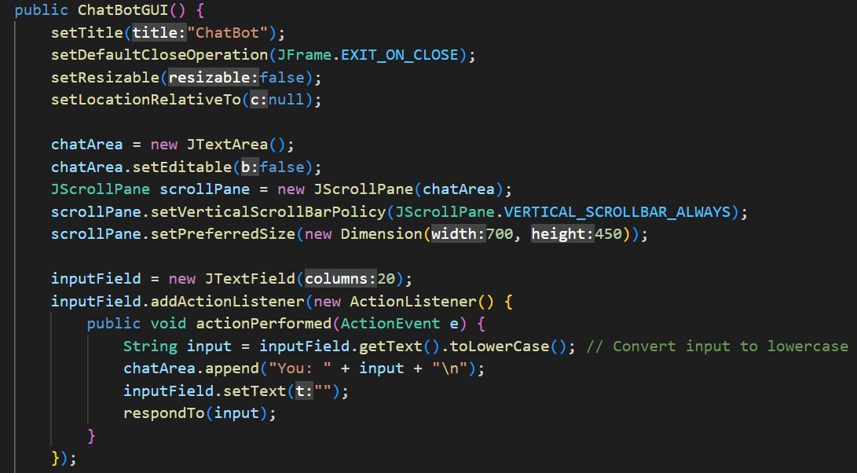

First response:

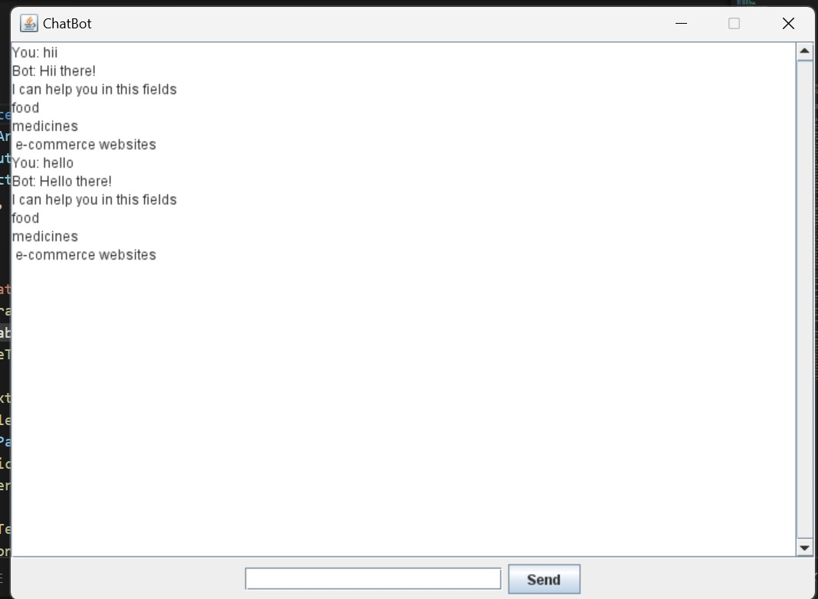

Food response:

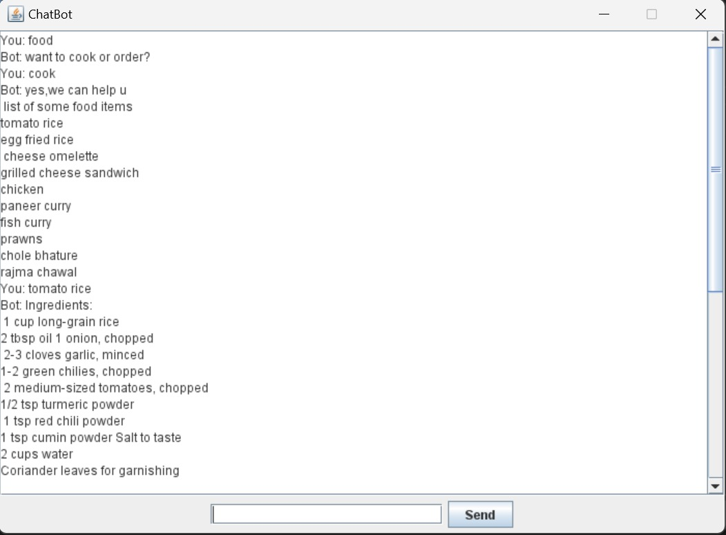

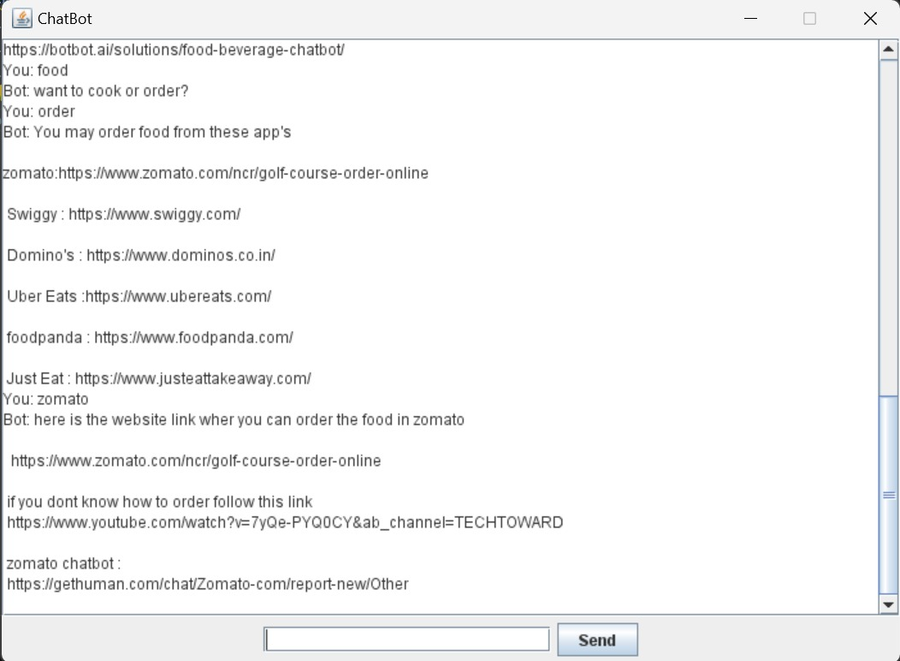

Medicine response:

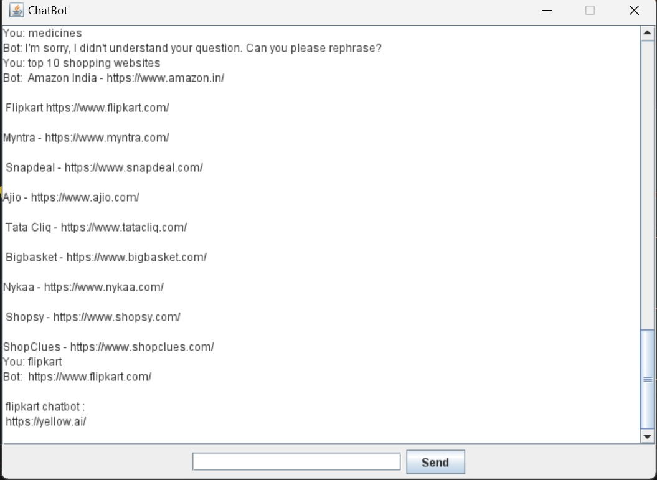

E-Commerce response:



**Conclusion:** A chatbot is one of the simple ways to transport data from a computer without having to think for proper keywords to look up in a search or browse several web pages to collect information; users can easily type their query in natural language and retrieve information. In this paper, information about the design, implementation of the chatbot has been presented. From the survey above, it can be said that the development and improvement of chatbot design grow at an unpredictable rate due to variety of methods and approaches used to design a chatbot. Chatbot is a great tool for quick interaction with the user. They help us by providing entertainment, saving time and answering the questions that are hard to find. The Chatbot must be simple and conversational. Since there are many designs and approaches for creating a chatbot, it can be at odds with commercial considerations. Researchers need to interact and must agree on a common approach for designing a Chatbot. In this project, we looked into how Chatbots are developed and the applications of Chatbots in various fields. In addition comparison has been made with other Chatbots. General purpose Chatbot must be simple, user friendly, must be easily understood and the knowledge base must be compact. Although some of the commercial products have recently emerged, improvements must be made to find a common approach for designing a Chatbot.